Letting Go
In order to experience something new, we have to let go of what was and is. This is sometimes the only thing left to do. The question is how?

Letting Go
By Kathy Kirk, Contributing Editor of Bringing More Life into the World
It's the New Year. It's the time we evaluate what stays and goes in our life: beliefs or jobs, habits or clothes, behaviors or people. The New Year is where we clean house, making room for what we want to come into our lives next. In order to make room, we have to first let go.
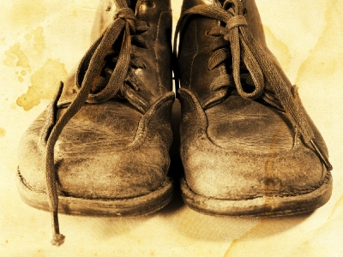
How many times have you heard, "Just let it go!"
Well, of course you would let it go, if you knew how, right? Recently a friend was talking about letting go of an old habit. She said, "You know, Kath, I'd flip that switch if I knew where it was located."
I understand - completely. It's often easier said than done. Yet, having said that, we must if we want to move forward, expand, and create new experiences. Clinging to the old, whether it is an idea, a belief, a habit or a sofa only nets us more of the same.
Determining What Goes
What goes is anything that no longer serves you and dream for your life. Just like a pair of old shoes that you've worn on your daily run, they are worn out and no longer serve you well. It's time to replace them with something that fits, supports and serves your new desires.
Let's say you've been running at the gym on a treadmill machine, and now you want to run outdoors. This new desire to expand your experience calls for a different shoe that will take the demands of the open road. Maybe you've been running on the open road and now you want to do some cross country or trail runs, which calls for yet another shoe to support that experience.
Likewise if you're wanting to experience in the New Year the feeling of more freedom, more joy, more of anything "good", then you'll need to pitch out those limiting beliefs that have held you to your present state of experience.
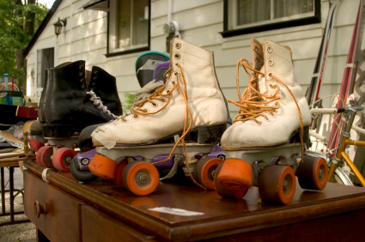
What you let go of is determined by the feeling of it pinching, just like a pair of shoes that you've outgrown.
Does the habit, thought, idea or behavior "pinch" you when you consider it? Do you flinch, wince or otherwise cringe? If so, it is on the let it go list. This applies to anything in your life. If it doesn't feel good to you any longer, it's off to the great redemption center, whether it is cosmic or the corner recycle shop.
How to Let It Go
Often letting go of physical things is the metaphor for releasing stuff from your inner world. A friend asked me to help him tackle cleaning out his basement. He was, of course, overwhelmed at the task which is why I was invited to the party.
We surveyed 2000 sq. ft. and 30 years of stuff. Of course, I had no attachment to his stuff, but naturally, he did. We began with one box, one bite, one step at a time. While he evaluated the contents determining its current value to him, I was there as a ballast to maintain balance. We made three piles in one corner of the basement: one to keep, one to give away, and one to throw away.
Obviously this process took weeks, but the entire process was my friend's journey of review and letting go. He revisited old times, remembered and reviewed many things and experiences; he came to peace with some things, and came to cherish others. In the end he let go of lots of stuff, both physical and emotional. It was cathartic, healing and above all - freeing. It was also conscious, deliberate and intentional.
It’s no coincidence that you might find yourself cleaning out drawers or scrubbing the kitchen when you’re in the midst of letting something go…worry, working something out, etc.
Letting go is releasing something to its own life whilst reclaiming the energy given over to it for yourself. It is a process accomplished over time, and always begun with the desire and intention to be free and happy.
A Natural Process
The process is natural and inevitable: that of moving forward and letting go. We do it all the time, sometimes willingly and consciously like my friend. Sometimes it is done unconsciously, like when we lose something we thought we valued – a home in a fire, a ring down the drain, or a job.
We are eternal and infinite creatures always having new adventures. In fact it is our essential nature to explore the new and expand. We are constantly evolving and changing just like the seasons of the year whether we aware of it or not.
Life is just so much more delicious and fun when we choose what’s next, decide to release what we’re done with, and enjoy the entire process consciously and intentionally.
That just might be a New Year’s Resolution worth keeping.

